Operating system
TASK 05
Name Nabiha Sabir
Roll no : SU92-BSSEM-S24-019
Section : 4A
Lab Task 1 – execlp Basics
• Run a Python script using execlp.
• Replace the current process with another Python file.
• Pass at least three arguments to the script.
• Verify that the parent’s last print() is never executed.
Code
import os

print("Before execlp call in parent")

os.execlp("python3", "python3", "child1.py", "arg1", "arg2", "arg3")

print("This line should never print (execlp replaced process)")
python code
import sys

print("Child script started")
print("Arguments received:", sys.argv)
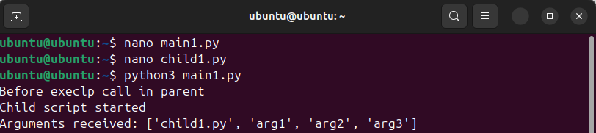

Lab Task 2 – execvp with Fork
Use fork() and execvp.
• Fork a child process.
• In the child: replace it with another Python script and pass arguments.
• In the parent: wait for the child and print a message after it finishes.
Python
import os

pid = os.fork()

if pid == 0:
args = ["python3", "child2.py", "Hello", "World"]
os.execvp("python3", args)
else:
os.wait()
print("Parent: Child has finished execution.")
nano child 2
import sys

print("Child running with arguments:", sys.argv)
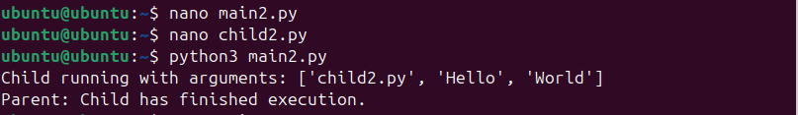
Lab Task 3 – execve with Custom Environment
Use execve.
• Run a program like env or another Python script.
• Pass a custom environment with only two variables.
• Show that parent’s environment is not available in the child.
python
import os

new_env = {
"USER": "CustomUser",
"PATH": "/usr/bin"
}

os.execve("/usr/bin/python3", ["python3", "child3.py"], new_env)
nano child 3
import os

print("Child environment:")
for key, value in os.environ.items():
print(f"{key} = {value}")
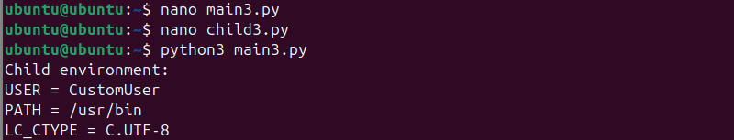
Lab Task 4 – execl vs execv
Compare execl and execv.
• Run the same script once with execl, once with execv.
• Pass the same arguments in both cases.
• Explain the difference in how arguments are provided.
Python code
import os

print("Running using execl:")
os.execl("/usr/bin/python3", "python3", "child4.py", "arg1", "arg2")
nano child 4
\ import sys
print("Child arguments:", sys.argv)
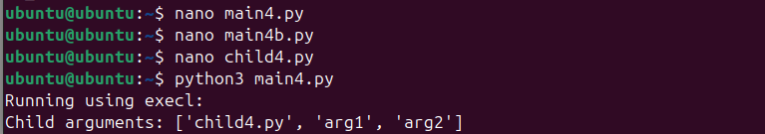
Lab Task 5 – execle with Environment
Use execle.
• Run a Python script.
• Pass one custom environment variable (e.g., MYVAR).
• Show that the script prints the value of this environment variable.
Python code
import os

my_env = {"MYVAR": "HelloWorld"}

os.execle("/usr/bin/python3", "python3", "child5.py", my_env)
nano child 5
import os

print("Child received MYVAR =", os.environ.get("MYVAR"))
